Addendum to Styles for APA Videos

The formatting for Head L2 in the videos is slightly off.

First, to be consistent with Stark, “Aligned at” for Head L2 must be 0.5" (see the screenshot below for Windows) as opposed to 0", which is what is shown in the videos.

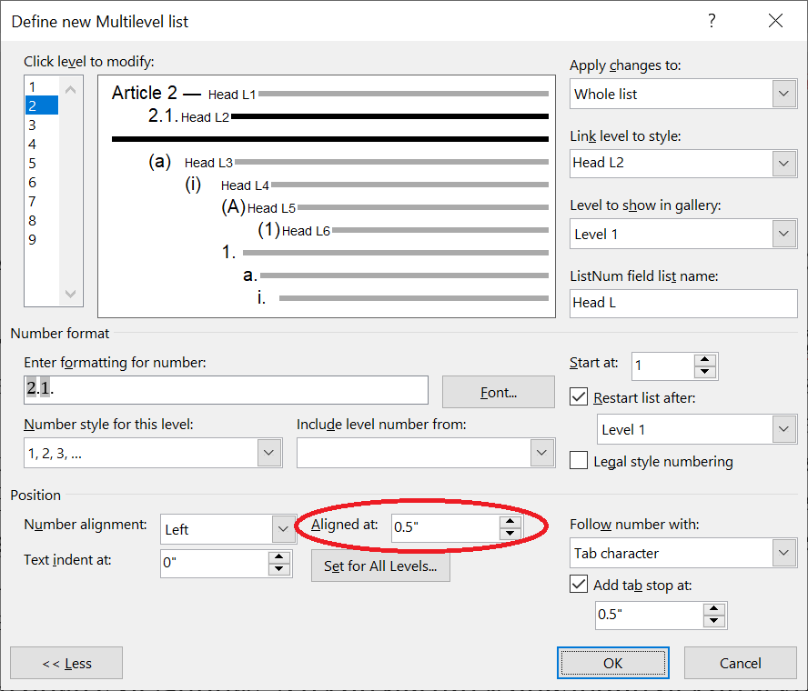

Second, so the number to Head L2 is bold (per Stark), click “Font” (see the screenshot below for Windows):

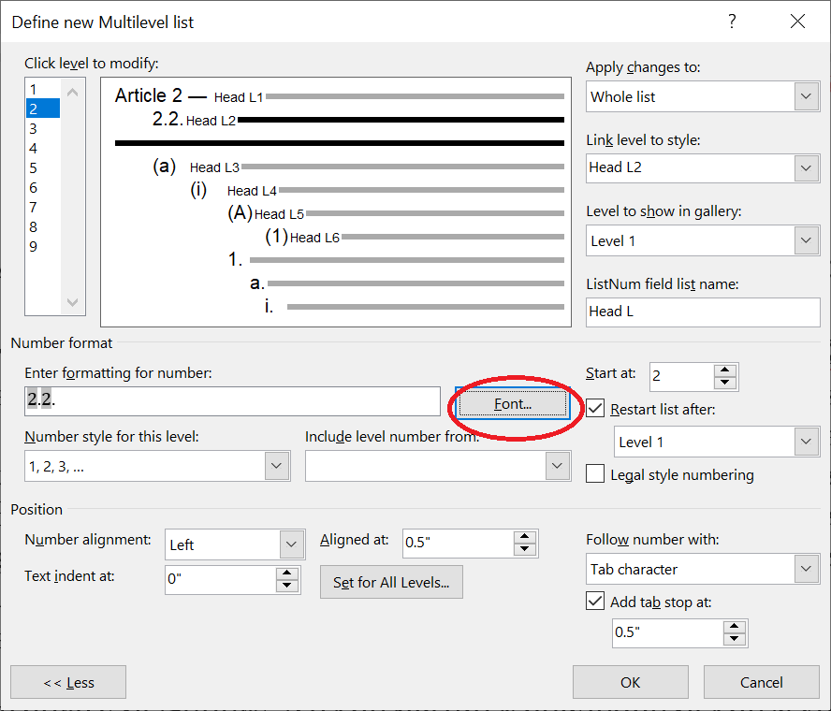

And then select “Bold” under “Font style” (see the screenshot below for Windows):

